1. **Create freestyle Jenkins job to download code from Git:-**

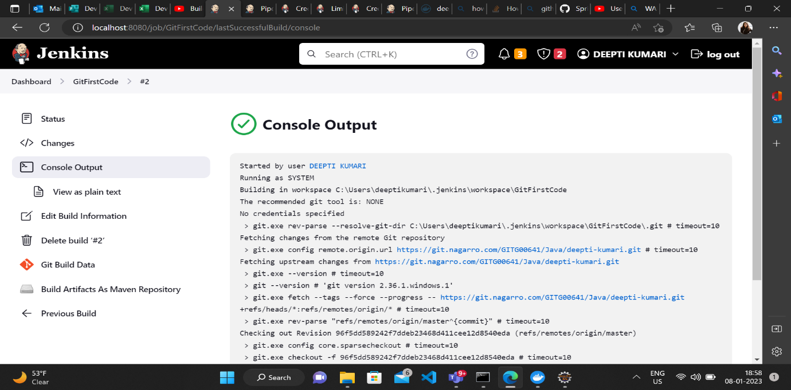

**2-Create pipeline to build and test basic springboot application**

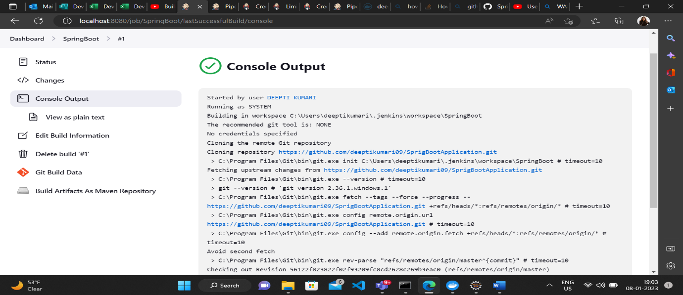

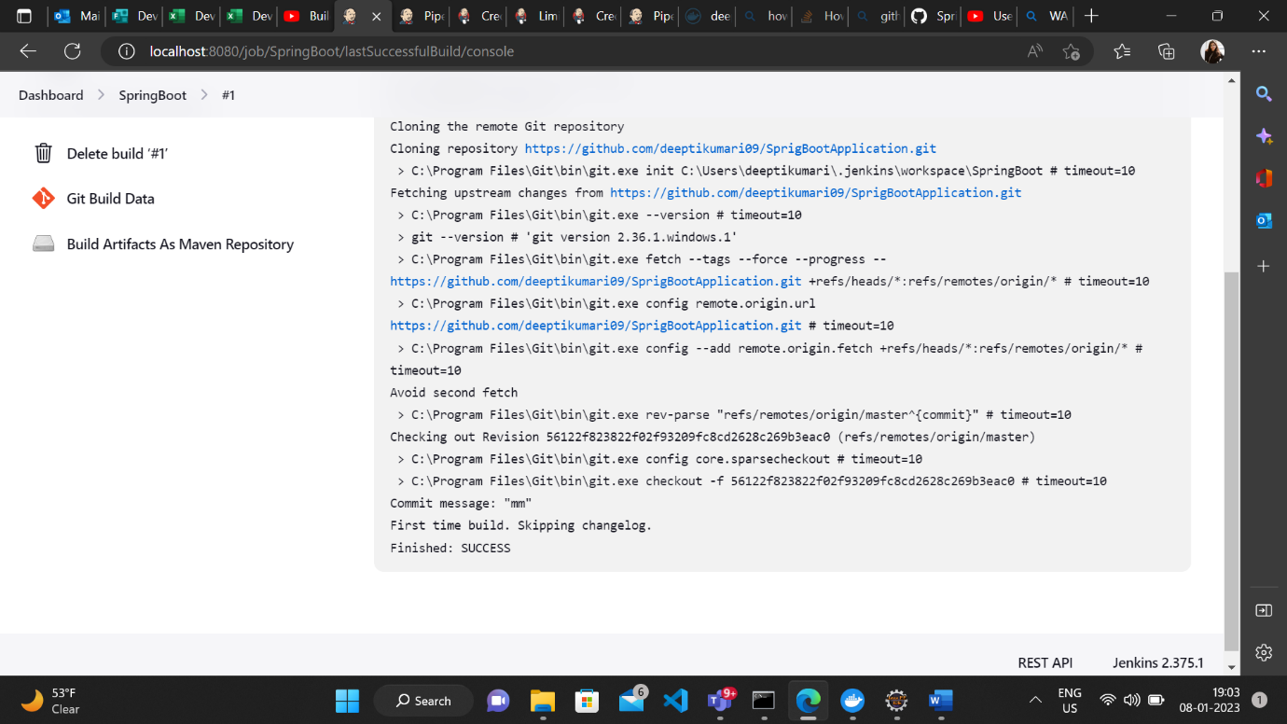

**3-Create freestyle Jenkins pipeline to build and deploy a spring boot API/Web App using Docker**



